FVIR Water Heater SRI8610C Gas Chromatograph tube locations: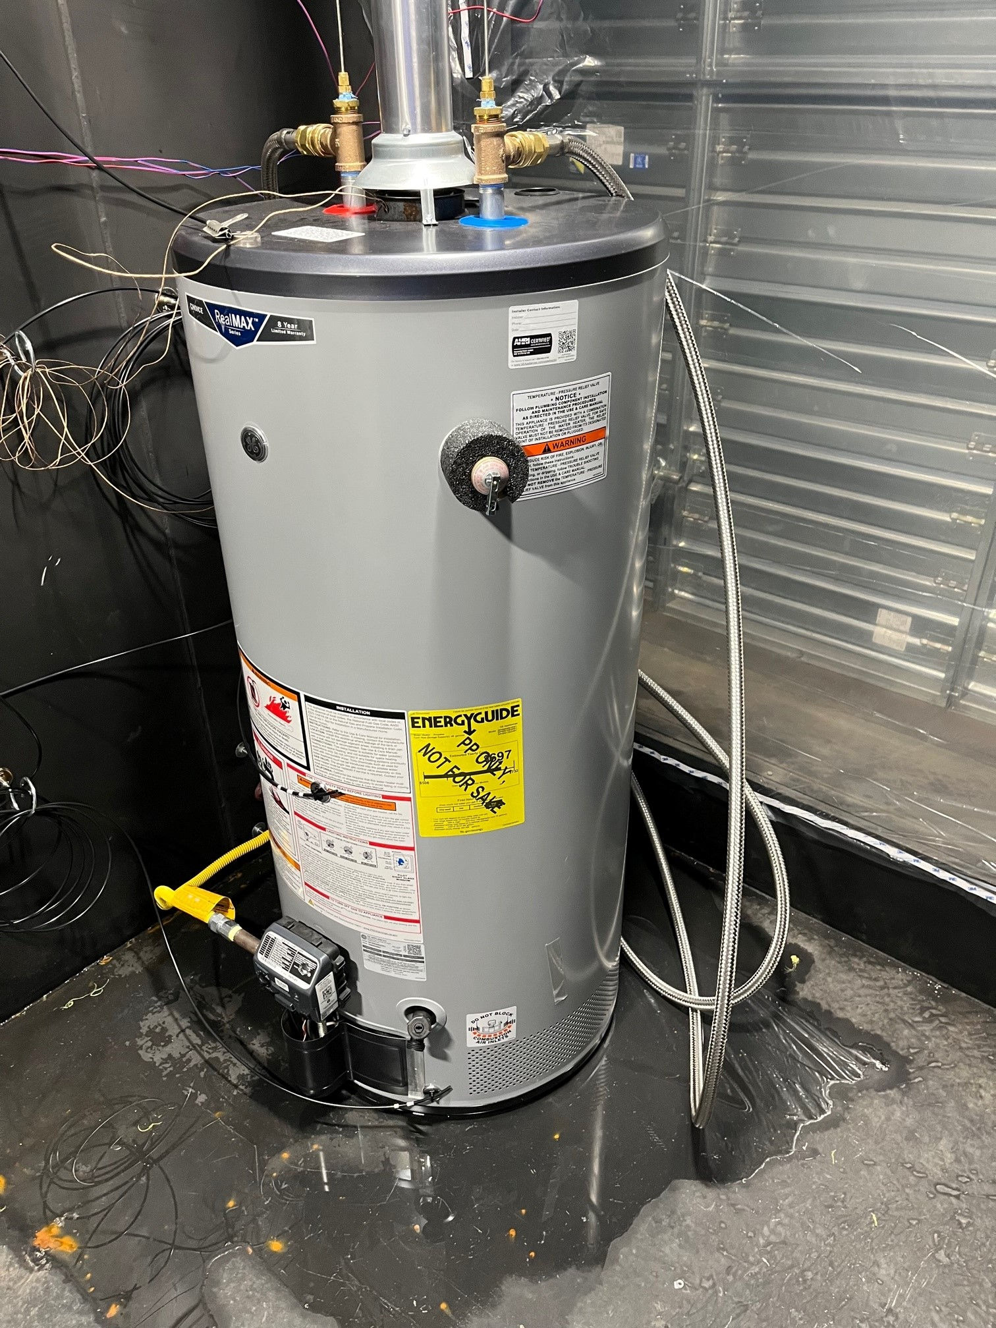

**GC Channel 1**

**GC Channel 3**

**(rear, opposite 2)**

**GC Channel 2**

**GC Channel 4**